Name: | _______________________________________________ |  |  | Date: _________
 | Year 10 Mathematics  Test 3, 2015  Topics –Surface Area and Volume |  |  | 55  = %
 | Total Time: 55 minutes | Weighting: | ~5% of the year.
 | Equipment Allowed: | Page notes (A4 one side), Calculator, Formula Sheet

1. | [4 marks: 1, 1, 1, 1]
 | Convert the measurements below
a. | 0.0059 m² to cm² | b. | 4.3 m³ to cm³
c. | 152.8 mm² to cm² | d. | 34855 mm³ to m³
2. | [3 marks]
12.3 m  4.7 m  5.2 m | Calculate the surface area of the following cuboid
3. | [5 marks: 3, 2]  15 cm  9 cm  12 cm  20 cm
 | Use the following shape to answer the questions
a | Calculate the surface area | b. | Calculate the volume
4. | [6 marks: 3, 3]
 | Calculate the surface area of the following shapes
a. |  | b.
 | 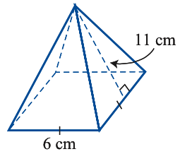 |  | 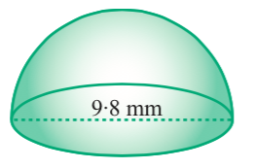
5. | [4 marks: 2, 2]
 | Calculate the volume of the following tapered shapes
a. | 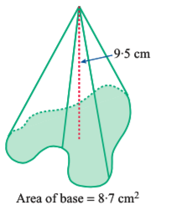 | b. | 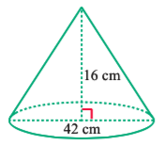
6. | [4 marks: 2, 2]
 | Use the following shape to answer the questions |  | 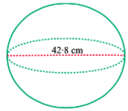
a. | Calculate the surface area | b. | Calculate the volume
7. | [4 marks]
 | What area of tin is needed to make an open box which is 4 cm deep with a base measuring 8 cm by 6 cm?
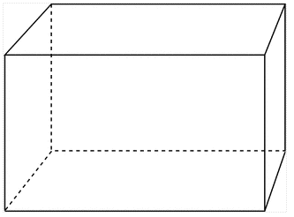
8. | [5 marks: 3, 2]
a | Use Heron’s formula to help you find the surface area of a triangular prism if the triangular ends have sides lengths measuring 6m, 7m and 8m and the prism is 11m long. If necessary, round your answer to two decimal places.
 | 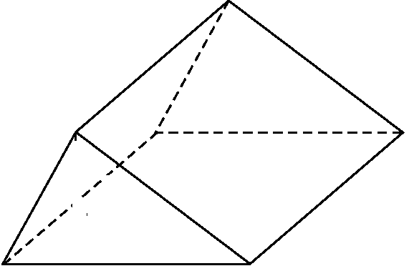
b. | Use your calculations from above to calculate the volume of the prism, give your answer to one decimal place.
9. | [5 marks]
 | Calculate the surface area of the following composite shape
 | 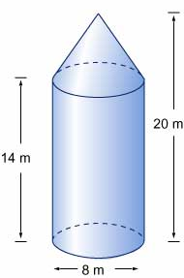
10. | [5 marks]
 | Calculate the volume of the following shape to the nearest mm³
67 mm
73 mm
58 mm
13 mm

11. | [5 marks]
 | The volume of a square based pyramid is given as 600 m³ and it has a perpendicular height of 12.5m. Calculate the surface area of one of its sides to the nearest m².
12. | [5 marks]
Oscar is interested in buying a fish tank in the shape of a rectangular prism that holds 250 L of water.
He finds a tank that is 1m long, 25cm wide and 10 cm tall. Will this tank be suitable?

End of Test

